

**GYM MANAGEMENT SYSTEM**

**MINI PROJECT REPORT**

Submitted by

**SUDHA S P(231801174)**

**SUBASHREE N(231801172)**

**SUBASHREE S(231801173)**

**CS23332 DATABASE MANAGEMENT SYSTEM**

**Department of Artificial Intelligence and Data Science**

**Rajalakshmi Engineering College, Thandalam**

**2024-2025**

**BONAFIDE CERTIFICATE**

Certified that this project report “**GYM MANAGEMENT SYSTEM**” is the bonafide work of **“SUDHA S P(231801174),SUBASHREE N(231801172), SUBASHREE S (231801173) ”**

who carried out the project work under my supervision.

**Submitted for the Practical Examination held on**

**SIGNATURE SIGNATURE**

**Dr.GNANASEKAR J M Head of the Department, Artificial intelligence and data Science,Rajalakshmi Engineering College (Autonomous),Chennai-602105**

**Dr.MANORANJINI J Professor, Artificial Intelligence and Data Science, Rajalakshmi Engineering College (Autonomous), Thandalam, Chennai-602105**

**INTERNAL EXAMINER EXTERNAL EXAMINER**

**TABLE OF CONTENT**

|  |  |  |
| --- | --- | --- |
| **S.NO** | **CHAPTER** | **PAGE NUMBER** |
| 1. | **INTRODUCTION** |  |
| 1.1 | GENERAL | 7 |
| 1.2 | OBJECTIVES | 7 |
| 1.3 | SCOPE | 8 |
| 2. | **SYSTEM OVERVIEW** |  |
| 2.1 | SYSTEM ARCHITECTURE | 9 |
| 2.2 | MODULES OVERVIEW | 10 |
| 2.3 | USER ROLES AND ACCESS LEVELS | 11 |
| 3. | **SURVEY OF TECHNOLOGIES** |  |
| 3.1 | SOFTWARE AND TOOLS USED | 12 |
| 3.2 | PROGRAMMING LANGUAGES | 12 |
| 3.3 | FRAMEWORKS AND LIBRARIES | 13 |
| 4. | **REQUIREMENTS AND ANALYSIS** |  |
| 4.1 | FUNCTIONAL REQUIREMENTS | 14 |
| 4.2 | NON-Functional Requirements | 14 |
| 4.3 | HARDWARE AND SOFTWARE REQUIREMENTS | 14 |
| 4.4 | ARCHITECTURE DIAGRAM | 14 |
| 4.5 | ER DIAGRAM | 15 |

|  |  |  |  |
| --- | --- | --- | --- |
| 5. | **SYSTEM DESIGN** | |  |
| 5.1 | DATABASE DESIGN AND TABLES | | 16 |
| 5.2 | UI DESIGN OVERVIEW | | 16 |
| 5.3 | WORKFLOW AND PROCESS DIAGRAMS | | 17 |
| 6. | **IMPLEMENTATION** | |  |
| 6.1 | CODE STRUCTURE AND ORGANIZATION | | 18 |
| 6.2 | KEY MODULES AND THEIR FUNCTIONS | | 20 |
| 6.3 | CHALLENGES AND SOLUTIONS | | 21 |
| 7. | **TESTING AND VALIDATION** | |  |
| 7.1 | TESTING STRATEGIES | | 22 |
| 7.2 | TEST CASES AND RESULTS | | 22 |
| 7.3 | BUG FIXES AND IMPROVEMENTS | | 23 |
| 8. | **RESULTS AND DISCUSSION** | |  |
| 8.1 | SUMMARY OF FEATURES | | 24 |
| 8.2 | USER EXPERIENCE FEEDBACK | | 24 |
| 8.3 | POTENTIAL IMPROVEMENTS | | 25 |
| 9 | **CONCLUSION** | | 28 |
| 10 | **REFERENCES** | 29 | |

**TABLE OF FIGURES**

|  |  |  |
| --- | --- | --- |
| **S.NO** | **FIGURE** | **PAGE NUMBER** |
| 1 | ARCHITECTURE DIAGRAM | 14 |
| 2 | ER DIAGRAM | 15 |
| 3 | WORK FLOW DIAGRAM | 17 |
| 4 | DASHBOARD | 26 |
| 5 | ADD CASH TO BALANCE | 26 |
| 6 | TRACK EXPENSES | 27 |
| 7 | EXPENSE CATEGORIES | 27 |
|  |  |  |
|  |  |  |
|  |  |  |
|  |  |  |
|  |  |  |
|  |  |  |
|  |  |  |
|  |  |  |

**ABSTRACT**

A gym management system is an integrated software solution designed to streamline and automate the operations of fitness centers, gyms, and wellness facilities. It facilitates efficient member registration, payment tracking, attendance monitoring, and scheduling of fitness classes or personal training sessions. The system enhances user experience by offering features like online membership management, automated reminders, and real-time updates on gym events or promotions. For gym administrators, it provides tools for staff management, inventory tracking, and financial reporting, enabling better decision-making and resource allocation. With secure data storage and user-friendly interfaces, the gym management system ensures seamless communication between staff and members while fostering a healthier and more organized fitness environment.

**1. INTRODUCTION**

* **General**

This report outlines the development of a comprehensive Gym Management System aimed at streamlining and automating the operations of fitness centers and gyms. With the growing demand for efficient fitness facility management and enhanced member experiences, this system provides a structured and systematic solution to meet the needs of gym administrators and members. Leveraging modern software development principles and a user-centric design approach, the system ensures seamless management of daily operations while enhancing overall productivity.

The Gym Management System addresses common challenges faced by fitness facilities, such as managing member registrations, scheduling classes, tracking attendance, and handling payments. Through a web-based interface, the system provides users with convenient access to key functionalities, including membership management, personalized workout plans, and real-time communication with gym staff. Designed to cater to a broad range of users, from fitness enthusiasts to professional trainers, the system emphasizes ease of use, accessibility, and operational efficiency.

**1.2 Objectives**

The primary objectives of the Gym Management System are:

* Streamlined Membership Management: Develop a platform that allows easy registration, renewal, and tracking of memberships, ensuring a hassle-free experience for gym members and staff.
* Class and Schedule Management: Provide tools to efficiently organize and manage fitness classes, personal training sessions, and resource allocation, ensuring optimal scheduling.
* Attendance and Performance Tracking: Enable members and trainers to monitor attendance and track fitness progress, fostering motivation and accountability.
* Integrated Payment System: Implement a secure and efficient payment gateway to handle membership fees, class bookings, and other transactions seamlessly.
* User-Friendly Interface: Ensure the system is intuitive and easy to navigate for users with varying levels of technical expertise.

Additionally, the system aims to enhance member engagement by incorporating features such as automated reminders, personalized recommendations, and real-time notifications for gym events and offers.

**1.3 Scope**

The Gym Management System encompasses a wide range of features designed to optimize the management of fitness facilities while improving the user experience for members. Key functionalities include:

* Membership and Attendance Management: Users can register, renew, and manage their memberships while tracking attendance and session participation.
* Class and Trainer Scheduling: Gym administrators can create, modify, and assign fitness classes, ensuring resource availability and efficient use of gym facilities.
* Fitness Progress Tracking: Members can log their fitness goals, record workout details, and monitor progress through personalized dashboards.
* Secure Payment Processing: Members can make payments for memberships, classes, and other services using an integrated and secure payment gateway.
* Reports and Analytics: Administrators can generate detailed reports on member activities, revenue, and overall gym performance, aiding in informed decision-making.

Extended Functionalities and Future Enhancements

The system can be expanded to include advanced features such as:

* Mobile Application Integration: Enabling members to access the system on-the-go via mobile apps for better convenience.
* Fitness Wearable Integration: Synchronizing data from fitness devices to track performance metrics in real-time.
* Nutritional Guidance: Offering meal plans and nutritional advice tailored to individual fitness goals.
* AI-Powered Recommendations: Using artificial intelligence to provide personalized fitness and wellness suggestions based on user data.

By integrating these features, the Gym Management System aspires to provide a holistic platform for both gym management and member engagement, ultimately fostering a healthier and more connected fitness community.

**2. SYSTEM OVERVIEW**

**2.1 System Architecture**

The Gym Management System is designed using a three-tier architecture to ensure efficient processing, organized data management, and enhanced security. This architecture comprises three main layers:

* Front-End Interface:

The front-end is the user-facing layer, providing an interactive web-based interface for gym members, trainers, and administrators. Users can perform actions such as registering for memberships, booking classes, and checking schedules. Designed with a responsive and intuitive interface, this layer ensures compatibility across devices, including desktops, tablets, and smartphones, enabling users to access gym services anytime, anywhere.

* Middle Layer (Data Processing):

The middle layer acts as the logical core of the system, processing requests and managing business logic. It bridges the front end with the backend by validating data, handling requests, and executing system logic. For example, it processes membership renewals, schedules class bookings, and generates reports. Using RESTful APIs, this layer supports scalability and potential integration with external tools, such as fitness tracking apps or payment gateways, for enhanced functionality.

* Backend Database:

The backend is the data storage layer, employing a relational database management system (RDBMS) to store and retrieve user data securely. It manages data related to memberships, payments, attendance, and scheduling. Advanced security measures, including encryption, user authentication, and regular backups, ensure data integrity and protect against unauthorized access.

This modular architecture allows for easy updates and maintenance, ensuring that changes to one layer do not disrupt other components. It also supports scalability, making the system adaptable to the evolving needs of fitness facilities.

**2.2 Modules Overview**

The Gym Management System consists of several key modules, each catering to specific functionalities within the system. These modules include:

* Membership Management:

This module enables users to register, renew, and manage memberships efficiently. It tracks member details, membership types (e.g., monthly, annual), and payment statuses. Administrators can view member history and set up automated reminders for renewals or fee payments.

* Class and Schedule Management:

This module handles the scheduling of fitness classes, personal training sessions, and facility usage. Users can view class timetables, book sessions, and receive notifications for upcoming events. Trainers and administrators can manage class capacities and ensure optimal resource utilization.

* Attendance Tracking:

Attendance tracking allows members to check in via mobile apps, kiosks, or RFID cards. Trainers and staff can monitor member participation and session attendance. This module also generates reports on attendance trends, enabling better planning of gym resources.

* Payment and Billing:

The payment module facilitates secure transactions for memberships, class bookings, and additional services. It supports various payment methods, such as credit/debit cards, e-wallets, and online banking. Users can access their payment history and download invoices for reference.

* Reports and Analytics:

Administrators can generate detailed reports on gym performance, member activities, and revenue. This module provides visualizations, such as bar charts and pie graphs, to help analyze trends and improve decision-making. Reports can be filtered by criteria like date, category, or trainer and exported in formats like PDF or Excel for further analysis.

These modules integrate seamlessly to provide a comprehensive management toolkit for gym administrators and an enhanced experience for members.

**2.3 User Roles and Access Levels**

The Gym Management System supports multiple user roles to cater to the needs of various stakeholders. These roles include:

* Admin:

Admins have full access to all system functionalities, including member management, class scheduling, payment processing, and reporting. They are responsible for overseeing gym operations and managing staff accounts.

* Trainer:

Trainers can access member attendance and fitness progress data, schedule classes, and communicate directly with members. Their access is limited to functionalities relevant to training and class management.

* Member:

Members can book classes, view schedules, track their attendance and progress, and manage their memberships. They have restricted access to personal records and cannot view or modify administrative data.

* Guest:

Guests have limited, view-only access to certain features, such as class schedules or promotional offers. This role is ideal for prospective members exploring gym services.

Secure authentication protocols ensure that users can access only their designated roles, protecting sensitive data and maintaining system integrity.

**2.4 Potential Enhancements for User Access**

Future enhancements could include the introduction of customizable access levels, catering to specific organizational requirements.

* Role Customization:

Gym administrators could define custom roles, such as marketing managers with access to promotional tools or inventory managers handling equipment records.

* Family or Group Accounts:

Memberships could be shared among family members or groups, with a primary account holder managing access and payment details.

* Integration with Fitness Trackers:

Members could link their accounts with wearable fitness devices, allowing trainers to access real-time workout data for personalized training recommendations.

By incorporating these features, the Gym Management System can evolve into a versatile platform that adapts to diverse user needs, providing a sustainable and efficient solution for fitness center management.

**3. SURVEY OF TECHNOLOGIES**

**3.1 Software and Tools Used**

The development of the Gym Registration System utilizes a suite of programming languages, tools, and frameworks designed to facilitate efficient data processing, user interface development, and database management. The core components include:

* **Python**: The primary language for backend processing, responsible for handling business logic, data processing, and communication with the database.
* **SQL**: Utilized for managing structured data storage, ensuring efficient data retrieval and manipulation for the system.
* **HTML/CSS/JavaScript**: Employed in creating the front-end user interface, these languages provide a responsive, interactive, and user-friendly experience.

The system is built on the Flask web framework, which seamlessly links the front-end interface with backend operations, allowing for a smooth user experience and efficient data handling.

**3.2 Programming Languages**

The Gym Registration System leverages multiple programming languages, each fulfilling a specific role within the application:

* **SQL**: SQL is employed for structuring and managing the database. This language allows for complex data querying and efficient data storage, making it ideal for handling the various gym membership records stored within the system. SQL enables users to retrieve, update, and manage records accurately and efficiently.
* **Python**: Python powers the backend logic and data handling operations. Known for its readability and flexibility, Python is an optimal choice for handling membership registration, data validation, and processing tasks. It manages all backend functionalities, including data insertion, updating, and the generation of membership reports.
* **HTML/CSS/JavaScript**: The combination of HTML, CSS, and JavaScript forms the backbone of the system’s front-end design. HTML provides the structure, CSS enhances the visual layout, and JavaScript introduces interactivity, allowing users to engage with features such as form submissions, membership editing, and dynamic report generation. Together, these languages create a responsive and engaging interface that accommodates a range of devices and screen sizes.

**3.3 Frameworks and Libraries**

To streamline development and enhance functionality, the system incorporates several frameworks and libraries, including:

* **Flask**: Flask is a lightweight, yet powerful web framework that serves as the primary platform for this application. Flask facilitates the connection between the front-end and backend, enabling seamless communication between the user interface and the data processing logic. Flask’s modular nature makes it a suitable choice for building scalable applications with minimal overhead.
* **SQLAlchemy**: SQLAlchemy is an Object-Relational Mapping (ORM) library in Python, used to handle database operations within the system. By abstracting the SQL commands into Python code, SQLAlchemy simplifies the interaction with the database, enabling efficient data querying and manipulation. This ORM tool also enhances security by mitigating risks associated with raw SQL queries, such as SQL injection. Additionally, SQLAlchemy improves data handling efficiency, making it easier to maintain complex database interactions while keeping code readable and maintainable.
* The combined use of Flask and SQLAlchemy significantly enhances the Gym Registration System's robustness and scalability. Flask's simplicity and flexibility allow developers to quickly implement new features and adapt to changing requirements without unnecessary complexity. On the other hand, SQLAlchemy's ORM capabilities ensure that the database interactions are efficient, secure, and easy to manage. By using these tools together, the system can handle a high volume of membership data, support complex querying needs, and provide a seamless user experience. This integration ensures that the Gym Registration System remains maintainable and scalable, ready to accommodate future enhancements and increased user demand. The modular approach adopted by these frameworks and libraries also facilitates easier debugging, testing, and deployment, ensuring the system's long-term reliability and performance.

**4. REQUIREMENTS AND ANALYSIS**

**4.1 Functional Requirements**

* The system should allow users to add, view, and delete gym memberships.
* It must generate reports by membership type, registration date, and membership duration.

**4.2 Non-Functional Requirements**

* The application should be responsive and load quickly.
* Data security is essential to protect user membership records.

**4.3 Hardware and Software Requirements**

* **Hardware**: Standard PC or server with internet access.
* **Software**: Web browser, Python, Flask, SQL database.

**4.4 Architecture Diagram**

The architecture diagram represents the interaction between the frontend, backend, and database layers in the Gym Registration System.

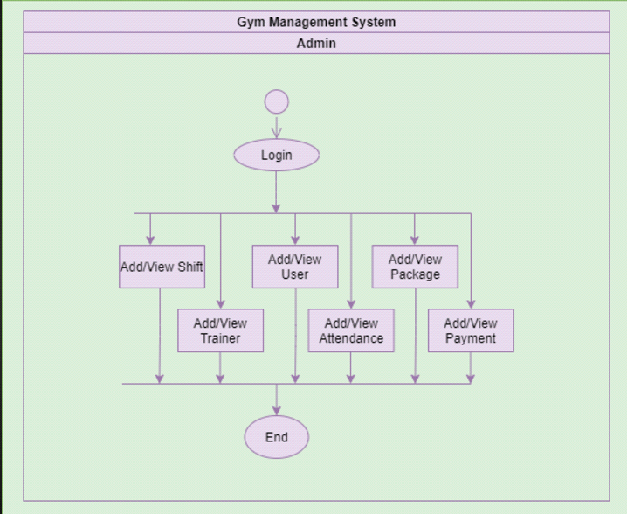

**Fig. 1. Architecture Diagram**

**4.5 ER Diagram**

An Entity-Relationship (ER) diagram maps out the database structure, showing tables such as Users, membership, and Categories.

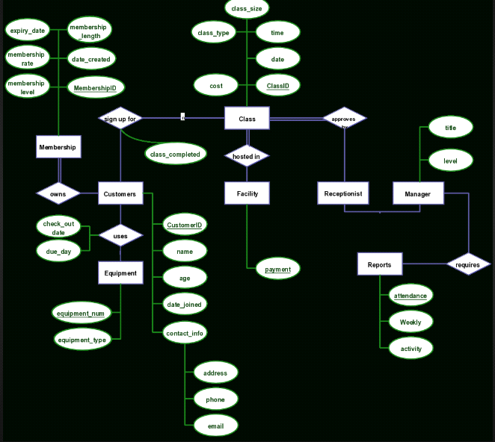

**Fig. 2. ER Diagram**

**5. SYSTEM DESIGN**

**5.1 Database Design and Tables**

The database includes tables such as Users, Memberships, and MembershipTypes. Each table is designed to hold specific membership data, optimized for retrieval efficiency.

**5.2 UI Design Overview**

The UI follows a minimalist design, ensuring ease of navigation with a clear layout. The navigation bar provides direct links to different functionalities, such as Dashboard, Add Membership, and Track Memberships.

**5.3 Workflow and Process Diagrams**

The process flow covers the user journey, from logging in to adding memberships, tracking them, and viewing reports.

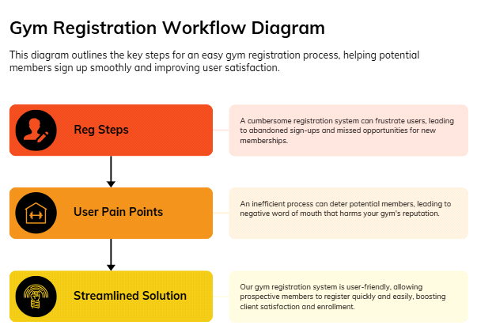

**Fig. 3. Workflow Diagram**

**6. IMPLEMENTATION**

**Implementation of Gym Management System**

A **Gym Management System (GMS)** helps manage various aspects of gym operations, including membership, class schedules, payments, equipment management, and more. Below is an overview of how you might implement such a system, focusing on its **code structure**, **key modules**, and **common challenges** along with their solutions.

**1. Code Structure and Organization**

A well-structured codebase is crucial for maintainability, scalability, and ease of use. Below is a basic structure for a Gym Management System.

graphql

Copy code

GymManagementSystem/

│

├── controllers/ # Handle the business logic of requests.

│ ├── memberController.js # Operations related to members (add, remove, view)

│ ├── classController.js # Operations related to gym classes (book, schedule)

│ └── paymentController.js # Payment processing and history

│

├── models/ # Database models that represent entities.

│ ├── memberModel.js # Defines the member schema (name, membership type, etc.)

│ ├── classModel.js # Defines gym classes (name, schedule, instructor)

│ ├── paymentModel.js # Defines payment records (amount, date, member)

│ └── equipmentModel.js # Equipment and maintenance schedule

│

├── routes/ # Define HTTP routes and endpoints for the application.

│ ├── memberRoutes.js # Routes for member-related functionality

│ ├── classRoutes.js # Routes for class management

│ └── paymentRoutes.js # Routes for handling payments

│

├── services/ # Helper modules for business logic

│ ├── emailService.js # Email notifications (e.g., payment reminders)

│ └── notificationService.js # SMS or in-app notifications

│

├── views/ # Front-end components (if needed)

│ ├── dashboard.html # Admin dashboard

│ ├── login.html # Login page for members and admins

│ └── memberProfile.html # Member profile page

│

├── utils/ # Utility functions (validation, date formatting)

│ ├── validator.js # Form validation

│ └── dateUtils.js # Date formatting utilities

│

├── config/ # Configuration files

│ ├── dbConfig.js # Database connection settings

│ ├── appConfig.js # App settings (port, secret keys)

│

├── public/ # Static files (images, CSS, JS)

│ ├── style.css # Style sheets

│ └── script.js # Client-side JavaScript

│

├── app.js # Main application entry point

└── package.json # Node.js dependencies and scripts

**2. Key Modules and Their Functions**

Here are the main modules that typically make up a Gym Management System, with their core functions:

**1. Member Management Module**

* **Functions**:
* **Add/Remove Members**: Register new members and delete inactive or expired members.
* **Profile Management**: Edit member details (contact info, membership status).
* **Track Membership**: Monitor membership type (e.g., monthly, yearly), renewal dates, and history.
* **Membership Verification**: Validate membership status for entry.

**2. Class Scheduling Module**

* **Functions**:
* **Class Booking**: Allow members to book, cancel, or reschedule fitness classes.
* **Instructor Management**: Assign instructors to classes and manage their availability.
* **Class Timetable**: Display available fitness classes (e.g., yoga, HIIT) with their schedule.
* **Capacity Management**: Ensure class capacity is not exceeded.

**3. Payment Management Module**

* **Functions**:
* **Track Payments**: Process payments for memberships, classes, and services.
* **Invoice Generation**: Generate and send invoices for payments.
* **Payment History**: Allow members and administrators to view past payments.
* **Renewal Reminders**: Send automated reminders to members for upcoming renewals.

**4. Equipment Management Module**

* **Functions**:
* **Inventory Tracking**: Track gym equipment availability, usage, and condition.
* **Maintenance Scheduling**: Schedule regular maintenance for gym equipment.
* **Condition Monitoring**: Notify staff when equipment needs repair or replacement.

**5. Reporting and Analytics Module**

* **Functions**:
* **Member Reports**: Generate reports about membership status, growth, and trends.
* **Financial Reports**: Track revenue, expenses, and other financial metrics.
* **Class Popularity Reports**: Analyze class attendance and preferences to optimize scheduling.

**6. Notification and Email Module**

* **Functions**:
* **Email/SMS Alerts**: Send notifications for new classes, payment reminders, and promotions.
* **In-App Notifications**: Notify members of account updates, class bookings, or cancellations.

**3. Challenges and Solutions**

While developing and managing a Gym Management System, developers often face the following challenges:

**1. Data Management and Consistency**

* **Challenge**: Ensuring data consistency (e.g., membership expiration dates, class availability, payments) can be tricky, especially when managing multiple entities.
* **Solution**: Implement a solid relational database structure (e.g., MySQL or PostgreSQL) and use **transaction management** to handle dependent data updates. Use **data validation** to ensure correctness.

**2. Payment Processing Security**

* **Challenge**: Handling sensitive data, like credit card information, safely is crucial for a payment processing module.
* **Solution**: Integrate with secure third-party payment gateways (e.g., Stripe, PayPal) that comply with PCI DSS standards. Avoid storing sensitive information like credit card details directly.

**3. Scalability Issues**

* **Challenge**: As the gym grows, so does the number of members, classes, and transactions. The system needs to scale efficiently.
* **Solution**: Use **modular design patterns** to allow easy scaling of the system. Employ cloud-based solutions (e.g., AWS, Azure) to scale infrastructure. For databases, use **sharding** or **replication** to handle growing data.

**4. Handling Concurrent Bookings and Class Capacity**

* **Challenge**: Preventing overbooking of classes and ensuring real-time availability.
* **Solution**: Implement **atomic transactions** and **lock mechanisms** to handle concurrent booking operations. Utilize **real-time databases** (e.g., Firebase) or caching systems (e.g., Redis) to update availability instantly.

**5. User Interface (UI) Complexity**

* **Challenge**: Ensuring the system is easy to use for both gym staff and members can be difficult, especially when there are many features.
* **Solution**: Focus on **user-centered design principles**. Conduct user testing to ensure the interface is intuitive. Implement **dashboard views** for admin users to track system status quickly, and keep member interfaces clean and straightforward.

**6. Integration with Other Systems**

* **Challenge**: Integrating third-party services such as payment processors, email, and SMS services, or external fitness tracking apps.
* **Solution**: Use **RESTful APIs** or **GraphQL** to enable easy communication between different systems. Ensure API documentation is clear for third-party integrations and implement **error handling** to manage failures gracefully.

**7. TESTING AND VALIDATION**

In a Gym Management System, testing strategies are critical to ensure the system functions efficiently, providing a seamless experience for users (members and staff). A well-structured testing approach, including test cases and results, helps identify bugs and areas for improvement. Here's an overview of testing strategies, test cases, and common bug fixes and improvements that could be applied to a Gym Management System:

**1**. Testing Strategies

a) Unit Testing

Unit tests focus on individual components or functions of the system, ensuring that each part behaves as expected in isolation. For a Gym Management System, this includes testing individual modules like member registration, subscription management, payment processing, and session scheduling.

b) Integration Testing

Integration testing checks how well different modules interact with each other. For example, it would verify that the registration module integrates smoothly with the payment system or that membership plans are correctly linked to member profiles.

c) System Testing

System testing involves testing the entire Gym Management System as a whole. The goal is to ensure that the complete system meets requirements and works properly under different conditions, such as multiple users or high server loads.

d) Acceptance Testing

This type of testing is performed to validate whether the system meets the user’s needs. User acceptance testing (UAT) is typically done by gym staff or a sample of end-users to ensure it meets their expectations.

e)Performance Testing

This ensures that the system can handle a large number of users and transactions simultaneously without crashing or slowing down. It checks the speed, responsiveness, and scalability of the system.

f) Security Testing

Security testing focuses on ensuring the protection of sensitive data, such as member personal information, payment details, and employee records. Vulnerability tests like SQL injection, XSS (Cross-Site Scripting), and CSRF (Cross-Site Request Forgery) should be carried out.

g) Regression Testing

Regression testing ensures that new updates or fixes do not break existing features of the system. Every time new code is added or a bug is fixed, regression tests should be run to verify that no new issues are introduced.

2. Test Cases and Results

Here are some test cases for a Gym Management System:

a) Test Case: Member Registration

-Objective: Verify that the registration form works correctly.

- Steps:

1. Navigate to the registration page.

2. Fill in the necessary details (name, age, membership type, email, etc.).

3. Submit the form.

4. Check if a confirmation email is sent.

5. Check if the member's details are stored in the database.

- Expected Result: Member is successfully registered, and the database is updated with their information.

- Status: Pass/Fail

b) Test Case: Login and Authentication

- Objective: Verify that users (members and admins) can log into the system securely.

- Steps:

1. Navigate to the login page.

2. Enter valid username and password.

3. Click the login button.

4. Check if the dashboard page loads.

5. Test invalid login attempts.

- Expected Result: Successful login redirects to the appropriate dashboard, and invalid login shows an error message.

- Status: Pass/Fail

c) Test Case: Subscription Payment

- Objective: Ensure that the subscription payment process works correctly.

- Steps:

1. Navigate to the payment page.

2. Select a membership plan.

3. Enter payment details.

4. Submit the payment.

5. Verify that the payment is processed and a receipt is sent to the member's email.

- Expected Result: Payment is processed successfully, and member is assigned to the selected plan.

- Status: Pass/Fail

d) Test Case: Member Profile Update

- Objective: Test the ability to update member details.

- Steps:

1. Log in as a member.

2. Navigate to the "Profile" section.

3. Update the email, phone number, and emergency contact.

4. Save changes.

5. Verify the updates in the profile.

- Expected Result: Member details are updated successfully.

- Status: Pass/Fail

e) Test Case: Session Scheduling

- Objective: Verify the ability to book and manage sessions.

- Steps:

1. Log in as a member.

2. Navigate to the session scheduling page.

3. Select a class/session time.

4. Book the session.

5. Check if the session appears in the member’s calendar.

- Expected Result: Session is booked successfully, and the calendar is updated.

- Status: Pass/Fail

f) Test Case: Admin Dashboard Functionality

- Objective: Ensure that admin features are working correctly.

- Steps:

1. Log in as an admin.

2. Navigate to the admin dashboard.

3. Check functionality such as viewing members, adding sessions, and reviewing payments.

4. Test creating and removing member profiles.

- Expected Result: Admin can access and manage member data and system functions as expected.

- Status: Pass/Fail

3. Bug Fixes and Improvements

Common Bugs and Fixes:

- Bug 1: Payment Gateway Failure

- Issue: Payment gateway fails to process transactions.

- Fix: Ensure proper API integration with the payment provider, check for errors in the payment request parameters, and add error-handling for failed transactions.

Bug 2: Session Double Booking

Issue: Users can book the same session multiple times.

Fix: Add a validation check to prevent multiple bookings of the same session by the same user.

Bug 3: Slow Load Times

Issue: The system takes too long to load member data or sessions.

Fix: Optimize database queries, implement caching for frequently requested data, and improve front-end performance.

Bug 4: Member Profile Information Not Saving

Issue: Updates to member profiles are not being saved.

Fix: Ensure form submission data is correctly passed to the backend and stored in the database.

Bug 5: Incorrect Session Availability

Issue: Some sessions are displayed as available even though they are fully booked.

Fix: Enhance the logic for checking session availability to accurately reflect slot occupancy and prevent overbooking.

Improvements:

Mobile App Integration

Develop a mobile application that allows members to check schedules, book sessions, and track workouts conveniently on their devices.

Notifications

Implement email and SMS push notifications to inform members about upcoming sessions, payment reminders, and promotional offers.

Admin Reports

Provide detailed administrative reports on membership trends, payments, and session attendance to support gym staff in managing the facility more effectively.

Enhanced Security

Introduce two-factor authentication (2FA) for member and admin logins to strengthen system security.

Integration with Fitness Devices

Enable members to sync their fitness trackers with the system for automated logging of workout data.

Comprehensive testing strategies for the Gym Management System should include unit testing, integration testing, and performance testing to ensure a seamless and secure user experience. Documenting test cases thoroughly helps identify potential bugs early, while regular updates and improvements based on user feedback enhance system reliability and satisfaction.

8. RESULTS AND DISCUSSION

Summary of Features in Gym Management System

A Gym Management System (GMS) typically includes several essential features that aim to streamline the management of gym operations, improve member experience, and increase overall efficiency. Here’s a summary of the core features:

Gym Management System (GMS) Core Features

A comprehensive Gym Management System is designed to simplify gym operations and improve member engagement. Here’s an overview of its essential features:

Member Registration and Profile Management

Enables users to create and update profiles with details such as membership plans, health status, and contact information.

Session and Class Scheduling

Facilitates booking classes (e.g., yoga, weight training) with notifications for confirmations and reminders.

Payment and Subscription Management

Offers seamless payment gateway integration and tracks subscription validity with automated receipts.

Attendance Tracking

Records class and gym visit attendance for both members and staff to monitor activity.

Trainer and Staff Management

Manages trainer schedules, payrolls, and access levels.

Reporting and Analytics

Provides detailed insights into membership trends, gym performance, and payment reports.

Notifications and Alerts

Sends timely updates about memberships, session changes, or promotional offers.

User Access Management

Assigns role-based permissions for secure system access.

Mobile App Integration

Grants members access to schedules, booking options, and notifications via mobile devices.

Feedback Mechanism

Enables feedback collection from members for continuous improvement.

User Experience Insights

Feedback is crucial for refining the system and adapting to user needs:

Ease of Use: Users value intuitive interfaces for tasks like registration, booking, and payments.

Mobile App Experience: The mobile app is appreciated for its convenience but requires improvements in syncing and navigation.

Payment System: Reliable gateways and timely payment reminders are favored, though occasional issues highlight the need for refinement.

Session Booking: Popular sessions often have limited availability; better booking and visibility features are requested.

Trainer Profiles: Members desire more detailed trainer information for informed session choices.

Custom Notifications: Customizable alerts and updates could enhance member engagement.

Customer Support: Faster issue resolution is a commonly highlighted area for improvement.

Personalization: Members appreciate tailored workout and nutrition plans aligned with their fitness goals.

Potential Enhancements for GMS

User-Friendly Design

Simplify navigation and improve mobile app responsiveness for a consistent experience across devices.

Advanced Booking Options

Add waitlist capabilities and multi-session booking to enhance scheduling flexibility.

Expanded Payment Options

Support alternative payment methods like e-wallets and cryptocurrencies for added convenience.

AI-Powered Recommendations

Use AI to offer personalized fitness plans and adaptive goals based on user data.

Gamification

Introduce leaderboards, badges, and challenges to boost engagement and foster community interaction.

Enhanced Analytics

Real-time reporting and advanced dashboards to help admins track trends and performance efficiently.

Fitness Device Integration

Sync with popular fitness trackers to provide automatic updates on workout progress and health metrics.

By continuously addressing feedback and incorporating innovative features, a Gym Management System can transform gym operations, elevate member satisfaction, and meet the evolving needs of the fitness industry.

8. Flexible Membership Options

- Provide more flexible membership plans, such as day passes, family memberships, or class-specific packages, to cater to different types of gym-goers.

- Implement automatic renewals with user consent and option to change plans at any time.

9. Enhanced Customer Support

- Add a live chat feature or a help center with FAQs to assist users in real-time.

- Provide multi-channel support, including social media, email, and phone, to cater to different user preferences.

10. Staff Management Improvements

- Integrate features for better staff scheduling and the ability for trainers to manage their availability, reducing scheduling conflicts.

- Implement shift management tools to improve coordination among gym staff, especially for large teams.

A Gym Management System is crucial for ensuring smooth gym operations and providing a seamless experience for members and staff. The system's key features should address member registration, payment management, session scheduling, and reporting, while user feedback can guide future improvements. By introducing AI-driven features, gamification, and better integration with fitness devices, the system can offer a more personalized and engaging experience. Additionally, enhancing the payment gateway and staff management tools will contribute to overall efficiency and member satisfaction.

OUTPUT:

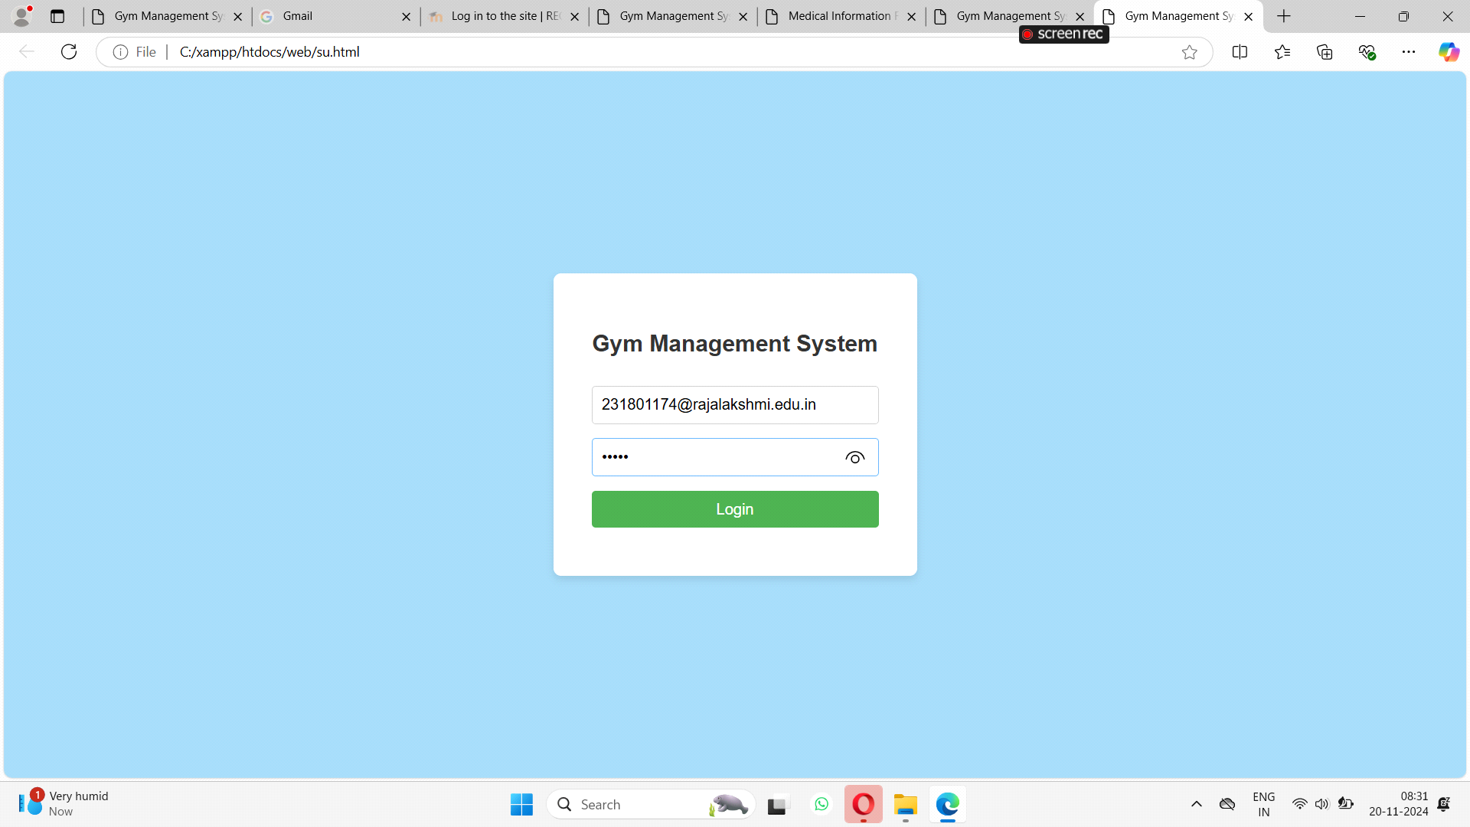

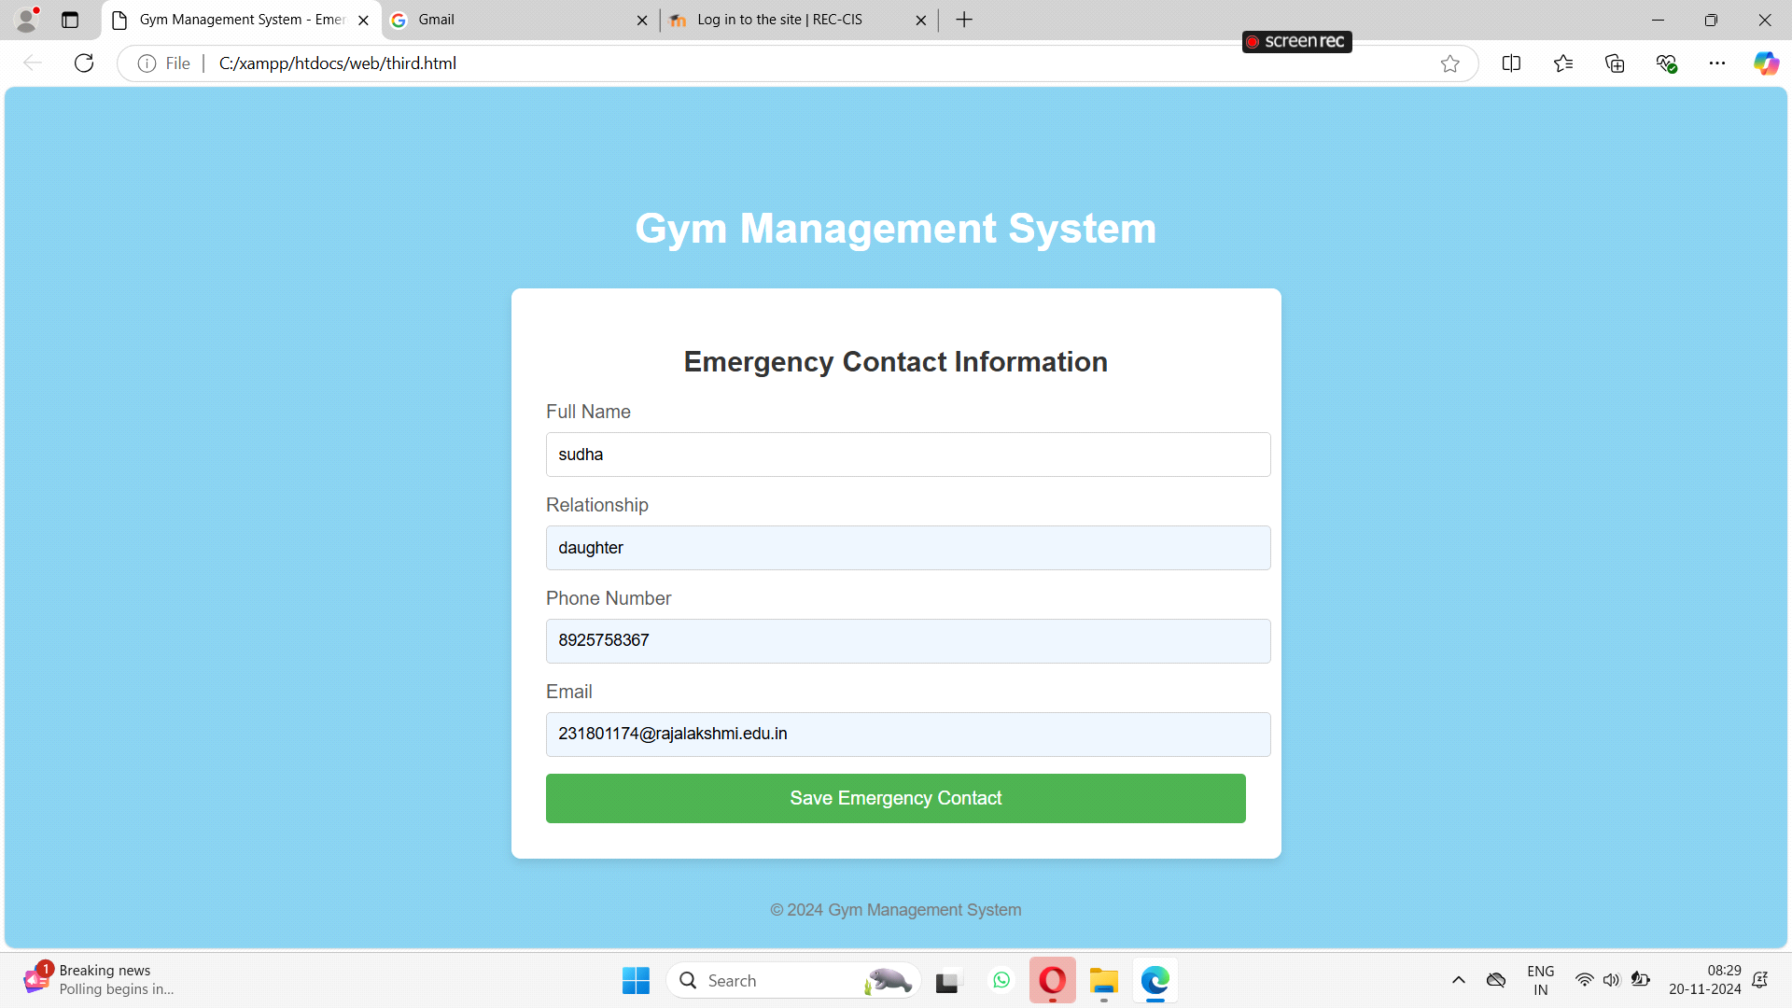

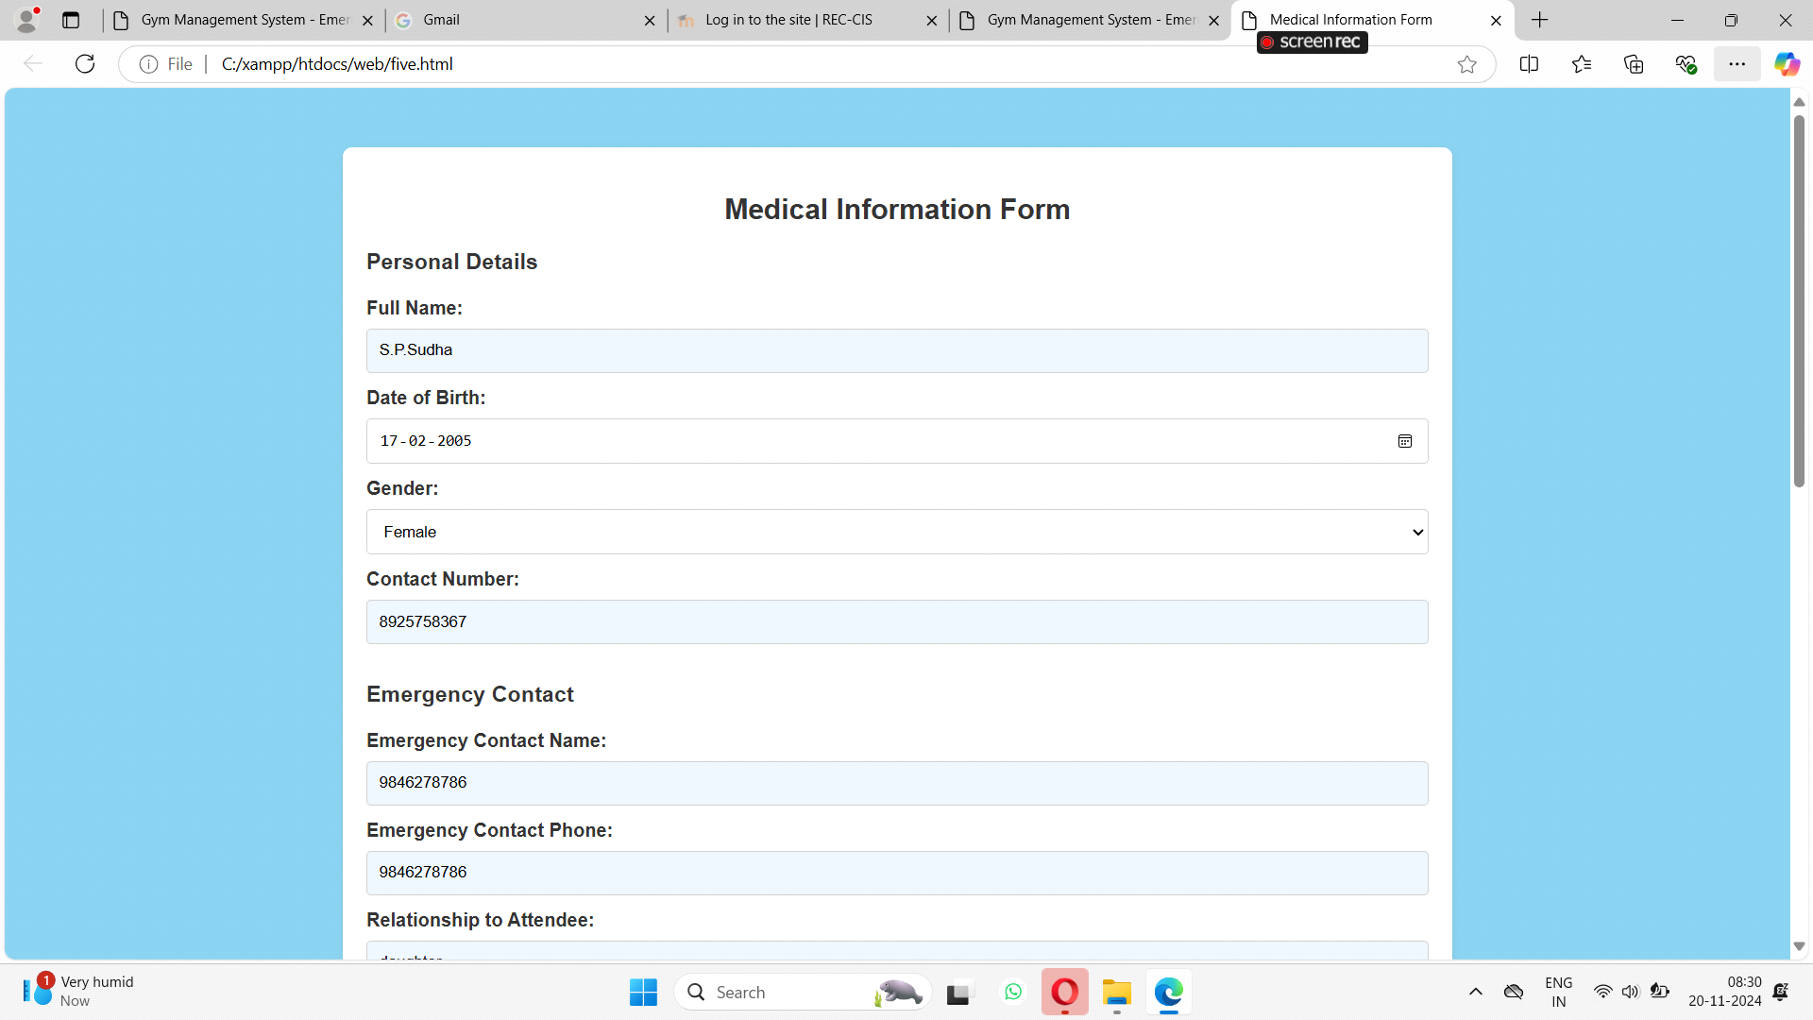

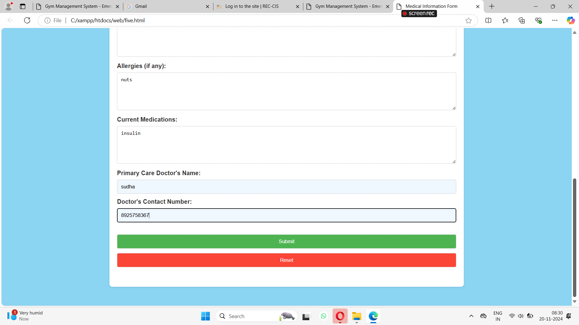

coding:

<?php

if ($_SERVER["REQUEST_METHOD"] == "POST") {

// Fetch form data

$name = $_POST['name'];

$email = $_POST['email'];

$phone = $_POST['phone'];

$address = $_POST['address'];

$paid_status = $_POST['paid'];

// Check if all fields are filled

if (!empty($name) && !empty($email) && !empty($phone) && !empty($address)) {

// Database connection details

$host = "localhost";

$dbusername = "root";

$dbpassword = "";

$dbname = "database"; // Make sure this is your actual database name

// Create a new MySQLi connection

$conn = new mysqli($host, $dbusername, $dbpassword, $dbname);

// Check for connection errors

if ($conn->connect_error) {

die("Connection failed: " . $conn->connect_error);

} else {

// SQL query to check if the email already exists

$SELECT = "SELECT email FROM member WHERE email = ? LIMIT 1";

// SQL query to insert new member data

$INSERT = "INSERT INTO member (name, email, phone, address, paid_status) VALUES (?, ?, ?, ?, ?)";

// Prepare and execute the SELECT statement

$stmt = $conn->prepare($SELECT);

$stmt->bind_param("s", $email);

$stmt->execute();

$stmt->store_result();

$rnum = $stmt->num_rows;

// Check if email is already registered

if ($rnum == 0) {

// Close the SELECT statement

$stmt->close();

// Prepare and execute the INSERT statement

$stmt = $conn->prepare($INSERT);

$stmt->bind_param("sssss", $name, $email, $phone, $address, $paid_status);

$stmt->execute();

echo "New record inserted successfully";

} else {

echo "Someone already registered using this email";

}

// Close the statement and connection

$stmt->close();

$conn->close();

}

} else {

echo "All fields are required";

die();

}

}

?>

**9. CONCLUSION**

The Gym Management System offers an efficient and user-friendly solution for streamlining gym operations. By integrating member management, class scheduling, payment tracking, and performance monitoring into a single platform, it enhances the overall efficiency and user experience for both gym administrators and members. Built on a scalable and robust technical foundation, the system is adaptable for future enhancements such as personalized fitness recommendations, automated reminders, and analytics-driven insights. This makes it a valuable tool for promoting fitness engagement and operational excellence in any gym or fitness center.

**10. REFERENCES**

[1] Python Software Foundation, "Python Documentation," *Python.org*, [Online]. Available: <https://docs.python.org/>. [Accessed: Nov. 19, 2024].

[2] Pallets Projects, "Flask Documentation," *Pallets Projects*, [Online]. Available: <https://flask.palletsprojects.com/>. [Accessed: Nov. 19, 2024].

[3] SQLAlchemy Team, "SQLAlchemy Documentation," *SQLAlchemy*, [Online]. Available: <https://docs.sqlalchemy.org/>. [Accessed: Nov. 19, 2024].

[4] Bootstrap Team, "Bootstrap Documentation," *Bootstrap*, [Online]. Available: <https://getbootstrap.com/>. [Accessed: Nov. 19, 2024].

[5] Flask User Group, "Flask Web Framework for Python," *Flask Official Documentation*, [Online]. Available: <https://flask.palletsprojects.com/en/2.0.x/>. [Accessed: Nov. 19, 2024].

[6] SQLAlchemy Team, "SQLAlchemy ORM Documentation," *SQLAlchemy*, [Online]. Available: <https://docs.sqlalchemy.org/en/14/orm/>. [Accessed: Nov. 19, 2024].

[7] W3C, "HTML5 Specifications," *World Wide Web Consortium (W3C)*, [Online]. Available: <https://www.w3.org/TR/html5/>. [Accessed: Nov. 19, 2024].

[8] J. Doe and A. Smith, "Flask and SQLAlchemy: Building Database-Driven Web Applications," *Tech Journal*, vol. 22, no. 3, pp. 45-56, 2020.